Learning Materials - Videos

- If you want to learn SoSci Survey we highly recommend to watch the tutorial videos: https://www.soscisurvey.de/de/screencast
- Further, if you want to get a basic understanding how JATOS is working we highly recommend to watch the following YouTube Video: https://www.youtube.com/watch?v=J1ELazppklQ

SoSci Survey

For a deeper understanding information on URL Parameters and SoSci Survey have a look at the respective page of the online SoSci Survey documentation: https://www.soscisurvey.de/help/doku.php/en:survey:url#marking_a_url_r

URL parameters explanation:
For a basic understanding: URL parameters are some kind of information that is transferred to a webpage (i.e. the server it lives on) when you open it via its web address (called “Uniform Resource Locator”; URL). You may have noticed that many web addresses have question mark at some point. URL parameters are the stuff that comes after the question mark. Normally they have a form like https://www.examplewebsite.org?someVariable=Something. You can have more than one URL parameter. To do so you append the second, third… parameter with a &, e.g.;
https://www.examplewebsite.org?someVariable=Something&otherVariable=SomethingElse&thirdVariable=whatever
If you want to extract the URL parameters copy the link for example in: https://www.matthewedgar.net/bulk-extract-url-parameters/

Connect SoSci Survey to CAMEL (using participant marketplace Prolific):
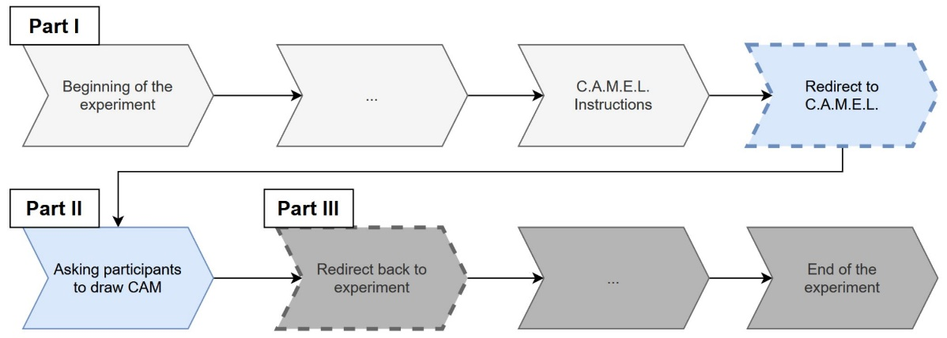
(c) Read Prolific ID again
(b) Redirect Prolific ID
(a) Read Prolific ID
Before start, please import the provided .xml file, which contains all the CAM projects of Michael Gorki. In our case you can ignore all project except “CAM-study_1a” and “CAM-study_1b”. Therefore create a project in Socio Survey and go to “project settings” (under “Survey project”) then “Import/Export” and upload the .xml file. If you click on “Compose questionnaire” you see all the Questionnaires in the left panel.

- Read Prolific ID
For our SoSciSurvey-example, we recruited participants on the online platform Prolific. There each participant has an ID. When participants opened the link to our study on Prolific, we set it up in a way, that Prolific transmitted the participants Prolific-ID as an URL parameter called r. That is the whole Link looks like https://www.linktoourstudy?r=ParticipantsProlific-ID. Thus, when a participant follows the link, SoSciSurvey gets the information r=ParticipantsProlific-ID.
On the first page of your questionnaire you have to read out this information. This is what the question “TE01” does. If you edit the question and open the sub-menu “variables (POST/GET)” you can see, that the content of the URL parameter variable “r” (i.e. what comes after “r=”) is stored into the internal SoSciSurvey variable “TE01_RV2”. Furthermore, as explained in the SoSciSurvey documentation, a URL parameter that is called “r” is a bit special, in the sense that you can access its information in the questionnaire if you insert a PHP snippet onto the respective page and enter “%reference%”.
- Redirect Prolific ID
That is, what we actually do on the second last page of the questionnaire (here page 33 in “CAM-study_1a”). Here we redirect the participant to the web-address where they can draw a CAM. At this point we use the ID that we received on the first page of the questionnaire and send it as an URL parameter with the name participantID (?participantID=theParticipants-ID) to the web-address where the CAM is drawn. (Storing it there is handled by the CAM-Software C.A.M.E.L that is expecting an URL Parameter with the name participantID).

- Read Prolific ID again
After participants have drawn their CAM, they are automatically redirected to the provided link (see “Set up study in the online documentation). In our case the second SoSciSurvey questionnaire “CAM-study_1b”. There again we read out the URL parameters and store their information as described above.

In that way, in the end we have the participants ID saved in the data of both SoSciSurvey questionnaires and in the CAM data. Thus, we can connect a CAM and participants answers on questionnaires they are presented after they have drawn their CAM.

